Network communication models

Network protocols video

Ethernet = governs network interface card to network interface card inside one network

IP = governs communication from original source till end devices

Makes sure that it will get there

TCP = makes sure the information arrives there reliably, and if it arrives not in correct order it makes sure it get reordered properly

HTTP = governs the exchange transfer

The protocol stack video

TCP/IP model (protocol stack)

Application HTTP

Transport TCP

Internet IP protocol

Network access ethernet protocol

The TCP/IP model

**Layered models help us visualize how the various protocols work together to enable   
 network communications**

A layered model depicts the operation of the protocols occurring within each layer, as well as the interaction with the layers above and below it

Benefits of layered model:

- assists in protocol design

- fosters competition

- enables technology changes to occur

- provides a common language to describe networking functions and capabilities’

**TCP/IP Model Layer = Description**

Application = represents data to the user, plus **encoding and dialog control**

Transport = **supports communication between various devices across diverse network**

Internet = **determines the best path through the network**

Network Access = **controls the hardware devices and media that make up the network**

The OSI reference model

2 types of models we use to describe the functions that must occur in order for network communication to be successful:

Protocol model

- It closely matches the structure of a particular protocol suite

- It includes the set of related protocols that typically provide all the functionality required for people to communicate with the data network (TCP/IP)

Reference model

- it describes the functions that must be completed at a particular layer, but does not specify exacly how a function should be accomplished

- it is not intended to provide a sufficient level of detail to define precisely how each protocol should work at each level

- its purpose is to aid in clearer understanding of the functions and processes necessary for network communications

Most known reference model is the OSI, it is used for data network design, operation specifications, and troubleshooting

**OSI model layer description**

7 - application it **contains protocols used for process-to-process communication**

6 - Presentation **provides for common representation of the data transferred between application layer services**

5 - session **provides services to the presentation layer to organize its dialogue and to manage data exchange**

4 - transport **defines services to segments, transfer, and reassemble the data for individual communications between the end devices**

3 - network **provides services to exchange the individual pieces of data over the network between identified end devices**

2 - data link **describe methods for exchanging data frames between devices over a common media**

1 - physical **describe the mechanical, electrical, functional and procedural means to activate, maintain, and de-activate physical connection for a bit transmission to and from a network device**

OSI model and TCP/IP model comparison

TCP/IP model is a method of visualizing the interactions of the various protocols that make up the TCP/IP protocol suite,

it doesn’t describe general functions that are necessary for all networking communications it only describes functions specific to those protocols in use in the TCP/IP protocol suite

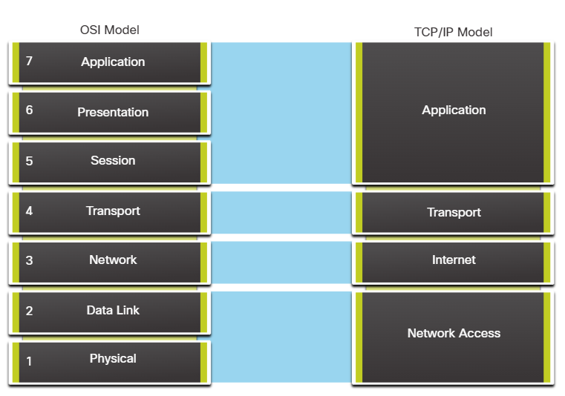

OSI layer 3 maps directly TCP/IP internet layer

This layer is used to describe protocols that address and route msg through internetwork

OSI layer 4 maps directly TCP/IPP transport layer

Describes general services and fuctions that provide ordered and reliable delivert of data between source and destination host

TCP/IP maps 5, 6, 7 protocol in OSI

Used as refereces for application software developers and vendors to produce applications that operate on the networks

Bouth are commonly used when referring to protocols at various layers

Because the OSI model separates the data link layer from the physical layer, it is commnly used when referring to these lower layers